TOPIC 3: TWO DIMENSIONAL SHAPES
Two dimensional shapes are essential shapes that can be represented on plain paper. This is because they only operate within two axes, which are the x-axis and the y-axis. Common example of 2D shapes include square, rectangles, triangles, circles etc
Objectives:
At the end of the session, the student will be able to:
- List and explain the properties of circle
- Solve problems relating to arcs and sectors of circle.
- Solve problems relating to the area of a triangle.
A circle is a simple, symmetrical 2-D shape. Its structure remains the same when rotated about its centre at any given angle. The usual unit of operation of these angles are in degrees, denoted by “$°$”, although it can also be measured in radius, where 360$°$=2$πrad$
PROPERTIES OF CIRCLE
- Diameter:
The diameter is a straight line drawn through the center of the circle from end to end, dividing the circle into identical semicircles.
- Radius
This is the common distance of the points on the edges or ends of the circle to its center. It is half of the diameter.
- Circumference
This is the perimeter or the length of the circle. It is the distance around the circle from one point on its end back to that same point.
- Chord
A chord of a circle is a line whose two end points lie on the circle. The diameter is the largest chord in the circle.
- Tangent
A tangent to a circle is a straight line that touches the circle at a single point.
- Arc
An arc is any connected part of the circle’s circumference.
- Sector
A sector is a region bounded by two radius and an arc lying between the radius.
- Segment
This is the region bounded by a chord and an arc lying between the chord’s end points.
- Secant
This is an extended chord, as it stretches out of the circle, cutting it at two points.
ILLUSTRATIONS
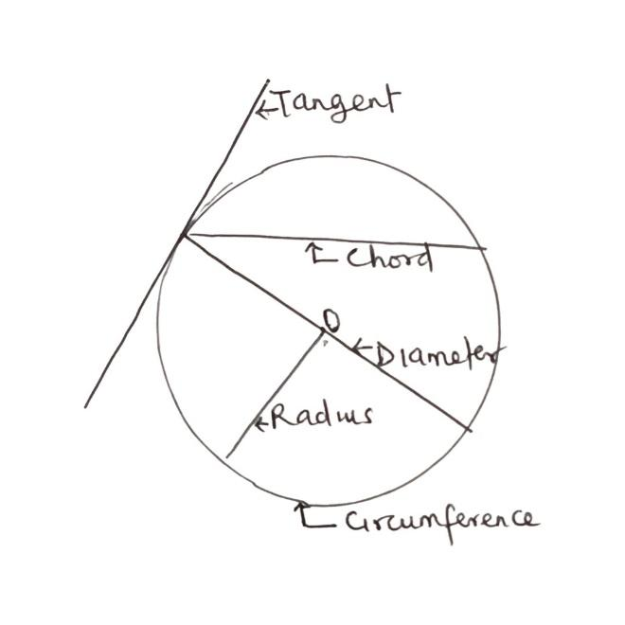 | 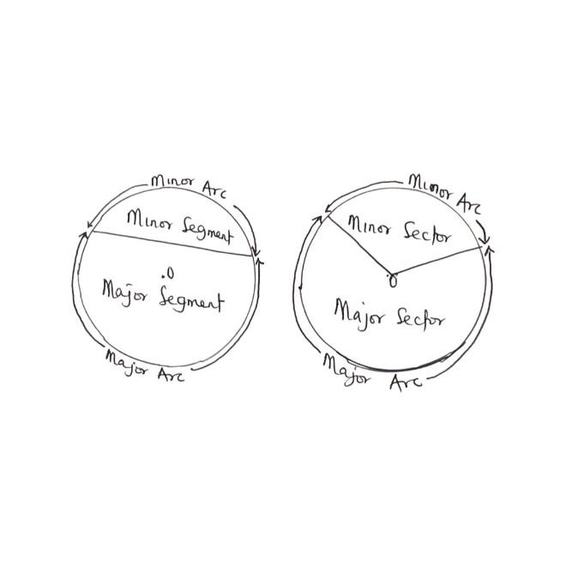
LENGTH OF AN ARC
The arc is the connected part of the circumference. Thus, if we consider that part of the circumference and take the distance along that arc, we would have the length of an arc.
Mathematically, given the angle of formation of the arc at the center as $θ,$ the radius as r, we can find the Arc Length as:
Length of arc= $\frac{θ}{360} ×2πr$
$2πr=circumference of circle$
Since 2r=d, which is diameter, then
Length of arc= $\frac{θ}{360} ×πd$; with $θ in degrees$
Notice that if $θ$is measured in radius, then Arc length=$θr$ since 360$°$=2$πrad$

PERIMETER OF SECTOR
To discover the total distance traveled along two radius and an arc lying between the radius, it suffices to find the perimeter of the resulting sector. Mathematically, given $θ as degree and r as radius$
Perimeter of sector= $\frac{θ}{360} ×2πr+2r$
Where $\frac{θ}{360} ×2πr$ = length of Arc
2r= distance along two radii
If $θ is in radius, then perimeter of sector= θr+2r$
Example:
- Find the length of arc and perimeter of sector subtended at 40 degrees at the center of radius 14cm. Take the value of $π to be \frac{22}{7}$
$$θ=40° r=14cm π=\frac{22}{7}$$
Length of Arc= $\frac{θ}{360} ×2πr$
=$\frac{40°}{360} ×2×\frac{22}{7}×14$
= $\frac{4×2×22×2}{36}$
= 9.78cm
Thus, the distance around the arc is 9.78cm
To find the perimeter,
Perimeter of sector= $\frac{θ}{360} ×2πr+2r$
= 2(14) + 9.78
= 28 +9.78
= 37.78cm
Thus, the distance around the minor sector is 37.78cm.
TRIVIA
A sector id termed minor if the angle it subtends is less than 180 degrees.
AREA OF A SECTOR
To deduce the area of the region bounded by two radius and an arc lying between the radius, we find the area of the resulting sector. Mathematically, given $θ as the angle in degrees and r as the radius$
Area of a sector= $\frac{θ}{360} ×2πr^{2}$
Where $πr^{2}=area of circle$
In $θ$as the radius, Area of sector=$\frac{θr^{2}}{2}$
In essence, the area of the sector is simply a portion of the area of the circle.
AREA OF SEGMENT
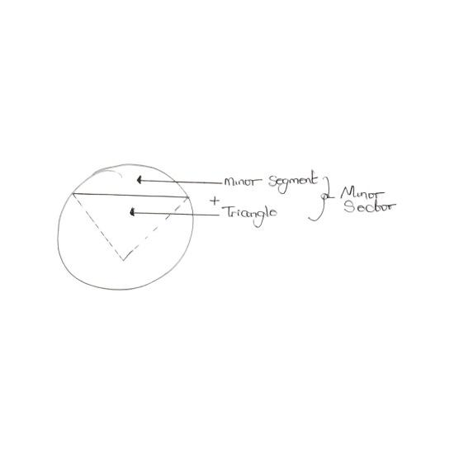 | 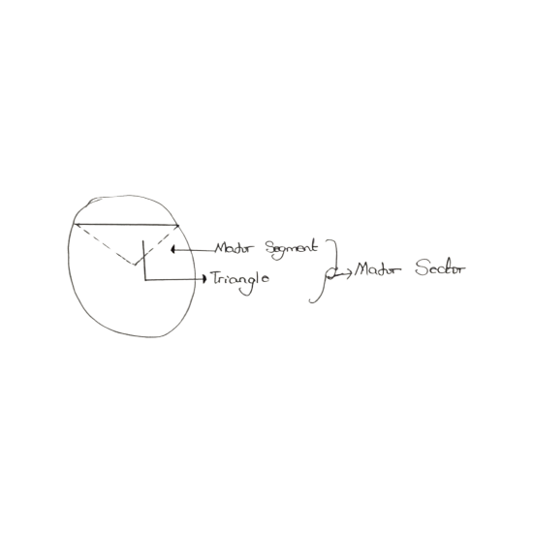
To calculate the area of the minor segment, it suffices to calculate the area of the minor sector and then subtract the Area of the triangle from it. To calculate the area of major segment, it suffices to calculate area of major sector and then adding the area of the Triangle to it.
Example:
- A circle subtends an arc of $125°$ at the center with a radius 7m. If the area of the resulting triangle bounded by the chord and two radii is 20$m^{2}$, calculate the area of the minor and major segment. Take $π=\frac{22}{7}$
First, we calculate the area of the minor segment

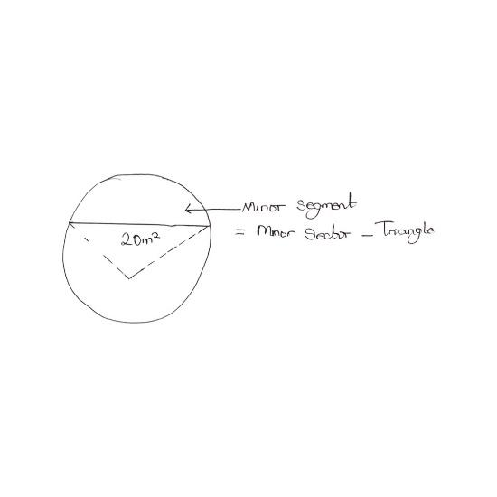
To proceed, we need to calculate the area of the minor sector
$$θ=125° <180° r=7m π=\frac{22}{7}$$
Area of minor sector= $\frac{θ}{360} ×πr^{2}$
= $\frac{125}{360}×\frac{22}{7}×7^{2}$
= 53.47$m^{2}$
Thus,
Area of minor segment= Area of minor sector- Area of triangle
= 53.47$m^{2}-20m^{2}$
= 33.47$m^{2}$
Next, we calculate the area of the major segment.
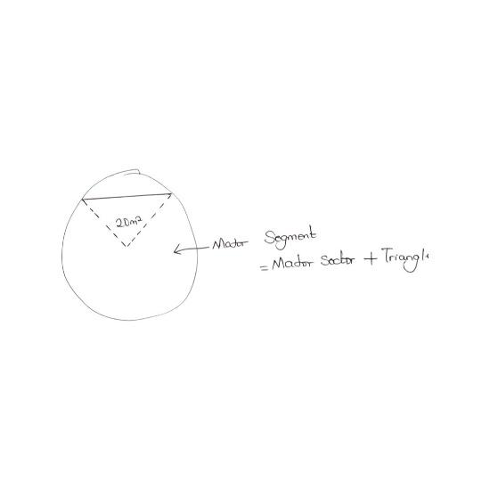
To proceed, we find the area of major sector
If angle of minor sector is 125$°,$ then angle of major sector is simply
$θ=360-125=235°; r=7m π=\frac{22}{7}$
Area of major sector = $\frac{θ}{360} ×πr^{2}$
= $\frac{235}{360}×\frac{22}{7}×7^{2}$
= 100.53$m^{2}$
Thus,
Area of major segment= Area of major sector + area of triangle
= 100.53$m^{2}+20m^{2}$
= 120.53$m^{2}$
AREA OF TRIANGLE
A triangle is a simple 3-sided 2-D shape. Its structure features 3 edges, with 3 predominant angles. Triangles are classified based on different criteria.
- BY ANGLE:
Triangles can be classified by angles into:
- Acute – angled triangle: has all 3 angles $<90°$
- Obtuse- angled triangle: has one angle $>90°$
- Right-angled triangle: has one angle =90
- BY SIDE:
Triangles can be classified by sides into
- Equilateral Triangle: has three equal sides
- Isosceles triangle: has two equal sides
- Scalene triangle: has no equal sides.

To calculate the area of triangle, it suffices to determine the base distance of the triangle, as well as the height.
Mathematically, given b as base length and h as the height
Area of Triangle= $\frac{1}{2}bh$

Example:
- Find the area of this triangle, with all values in cm
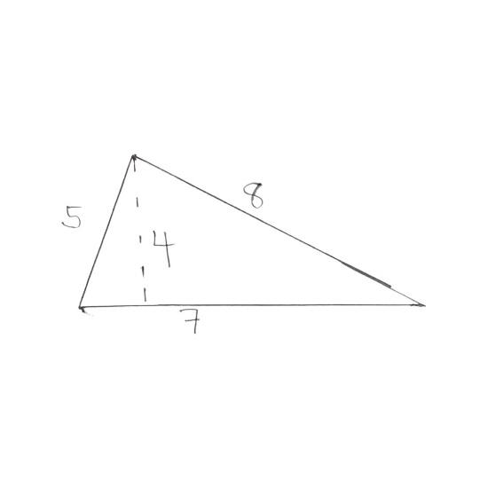
The base length is 7 and the height is 4
b = 7cm and h= 4cm
Area of Triangle= $\frac{1}{2}bh$
= $\frac{1}{2} . 7.4$
= 14c$m^{2}$
- The height of a triangle is 4m more than twice the length of the base. The area of the triangle is 35$m^{2}.$find the height of the triangle
h=4+2b and base length = b area =35
Area of Triangle= $\frac{1}{2}bh$
35 = $\frac{1}{2}$b(4+2b)
70=b(4+ 2b)
4b + 2$b^{2}=70$
$b^{2}+2b=35$
$b^{2}+2b-35=0$
$b^{2}+7b-5b-35=0$
b (b+7)-5(b+7)=0
(b+7)(b-5)=0
b = -7; b=5
Since the base length cannot be negative, then b =5m
Hence,
h = 4 +2b
h = 4+2(5)
h= 14m
DRILL
- If the Earth’s radius is 6371 meters, what is its circumference, taking $π=3.142,$ assuming it would be drawn, as is, on paper?
- Calculate the length of arc of a circle subtended at 30$°$ with radius 21cm. take $π=\frac{22}{7}$
- Determine the area of the segment, with an angle subtended at 49$°$ with radius 10m, if a chord of length 12m is 6m from the center of the circle. Take $π=\frac{22}{7}$
- Calculate the perimeter and area of the major sector that subtends and angle of 108$°$ at the center with radius 10cm. $π=\frac{22}{7}$
- Find the area of the triangle drawn on the graph

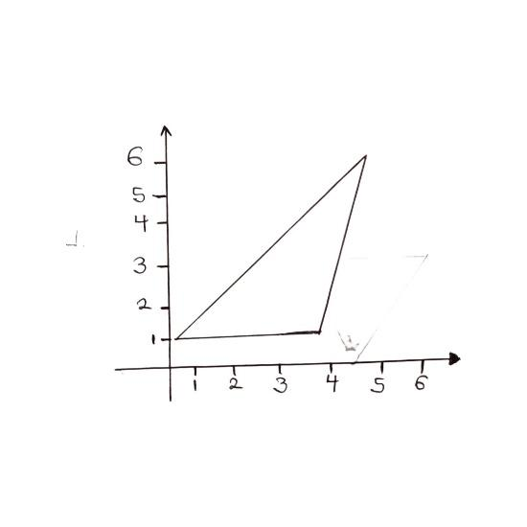
Scale: 2cm to 1unit meter for both axis
RECOMMENDATIONS
Cardboard sized chart displaying diagrams in page (2)
SOLUTION TO DRILL
- r = 6371m $π=3.142$
circumference = 2$πr$
= 2$×3.142×6371$
= 40035.364m
- $θ=30° r=21cm π=\frac{22}{7}$
Length of arc = $\frac{θ}{360} ×2πr$
=$\frac{30°}{360} ×2×\frac{22}{7}×21$

= 11cm
- $θ=49° r=10$
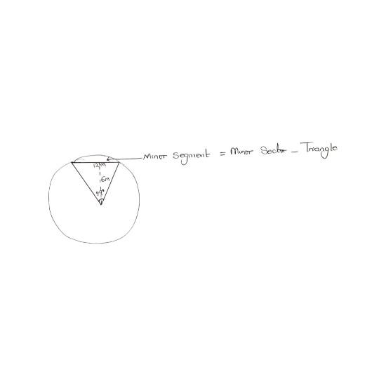
Area of minor sector= $\frac{θ}{360} ×πr^{2}$
= $\frac{49}{360}×\frac{22}{7}×{10}^{2}$
= 42.78$m^{2}$
For the triangle, base length = chord length= 12m
Height= 6m
Area of Triangle = $\frac{1}{2}$bh
= $\frac{1}{2}×12×6=36m^{2}$
Thus, Area of minor segment=Area of minor sector – Area of triangle
= 47.78$m^{2}-36m^{2}$
= 6.78$m^{2}$
- $θ=108° \left(minor sector\right)$
So, angle of major sector = 360$°-108°; r=10cm π=\frac{22}{7}$
= 252$°$
Perimeter of major sector= $\frac{θ}{360}×2πr+2r$
= $\left(\frac{252}{360}×2×\frac{22}{7}×10\right)+2\left(10\right)$
Perimeter of major sector = 44 +20
= 64cm
Area of major sector = $\frac{θ}{360} ×πr^{2}$
= $\frac{252}{360}×\frac{22}{7}×{10}^{2}$
= 22$×10$
= 220${cm}^{2}$
- From the readings on the graph,
Base length=b=4-0=4 (from x-axis)
Height= h= 5-1= 4 (from y-axis)
Area of triangle= $\frac{1}{2}bh$
= $\frac{1}{2}×4×4$
= 8$m^{2}$

